

2016

# DOMAIN AND HOSTING

RESERVATION

## PROJECTING OF INFORMATION SYSTEM

Sadman Amir, SM AKTERUZAMAN



1

TABLE OF CONTENTS

Introduction 2

Main Classes 2

Interaction Model 2

Use Case Diagram 3

Sequence Diagram 4

Sequence Diagram for the order confirmation 4

Sequence Diagram for the unavailability of the product 4

Activity Diagram 5

Class Diagram 6

State Diagram 7

State Diagram of Making Order 7

State Diagram of Making Delivery 8

Conclusion 8



2

### INTRODUCTION

This project is aimed at designing a model of Domain and hosting reservation system with usage of UML methods and techniques. Model is supposed to describe processes used in Domain and hosting reservation system .

Domain and hosting reservation System allows the company to manage domain and hosting allocation and manage with customer can browse and use to place orders with just a few clicks. The customers will have to choose whether he needs only domain or domain+hosting package. There will be a system administrator who will have the right to add and manage products; supervisors specific for different areas who will be sorting orders and assign delivery executives the delivery tasks. The customer will be in a position to view the available domain , register and place an order. There will be a confirmation receipt for each and every order made by the customer which can be printed.

The development of this system is executed using UML methods. This project is focused only in simple model of online delivery and doesn’t consider the full reality of complex system. In some parts of this project there are only some simply focused diagrams because purpose of this project is to design working model and not some complex part of reality.

### MAIN CLASSES

##### Person

It’s the superclass which will have subclasses like Customer, System Admin, Supervisor.

##### Customer

This class is able to view the Domain list and hosting package, make the order and pay with card. Customer class can also add and delete order before making the final decision.

##### System Admin

Add, view and manage the Domain and server allocation and at the end of the process confirms the specific deliveries.

##### Supervisor

Manages support , assign delivery executive a particular order to make the primary support and also deal with the payments.

### INTERACTION MODEL

Interaction model says how objects act to each other – it is an integral view over many objects. Interactions can be modeled at different abstraction levels:

* At top level – Use Case
* A more detailed view – Sequence Diagram
* Detailed view – Activity Diagram



3

### Use Case Diagram

Use Case describes the interaction of the system with its environment. We have shown the ways how the actor (customer, system admin and supervisor) can interact with the system.

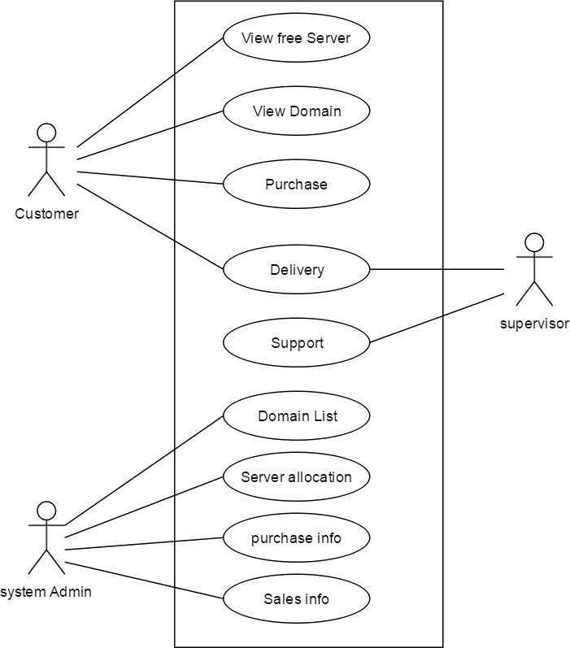



4

### Sequence Diagram

Sequence Diagrams shows participants of interactions and messages among them. We have used an actor (customer) and two systems to illustrate the sequence diagram.

#### Sequence Diagram for the order confirmation

First sequence diagram shows the exchange messages of confirming an order.

#### Sequence Diagram for the unavailability of the product

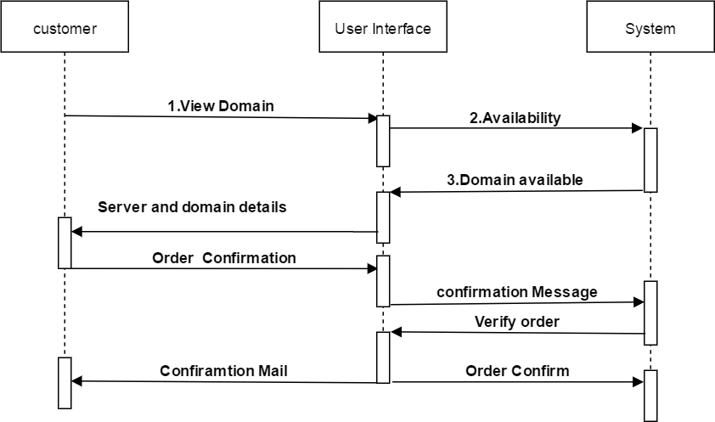



5

### Activity Diagram

Shows a control flow between individual steps of computation. It shows both data flow and control flow. Here the activity diagram shows a customer of searching, viewing and selecting Domain and making the final order and goes to the delivery state.

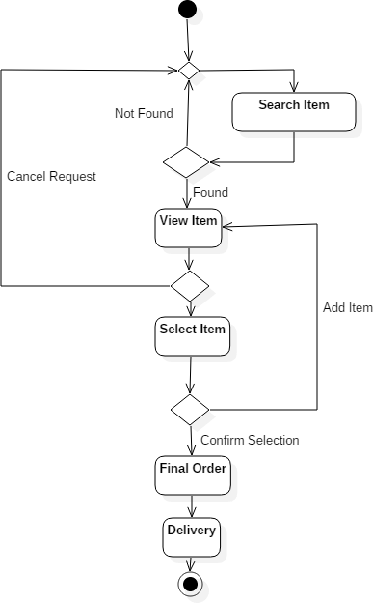



6

### CLASS DIAGRAM

A tool for accurate and easy expression of an object model. Attributes describe data feature of an object. Attributes are introduced in the second part of a class icon, separated from a class name by a horizontal line. Operation is a function or transformation which is performed by or at an object in the class. Operations are shown in the lower part of the class icon.

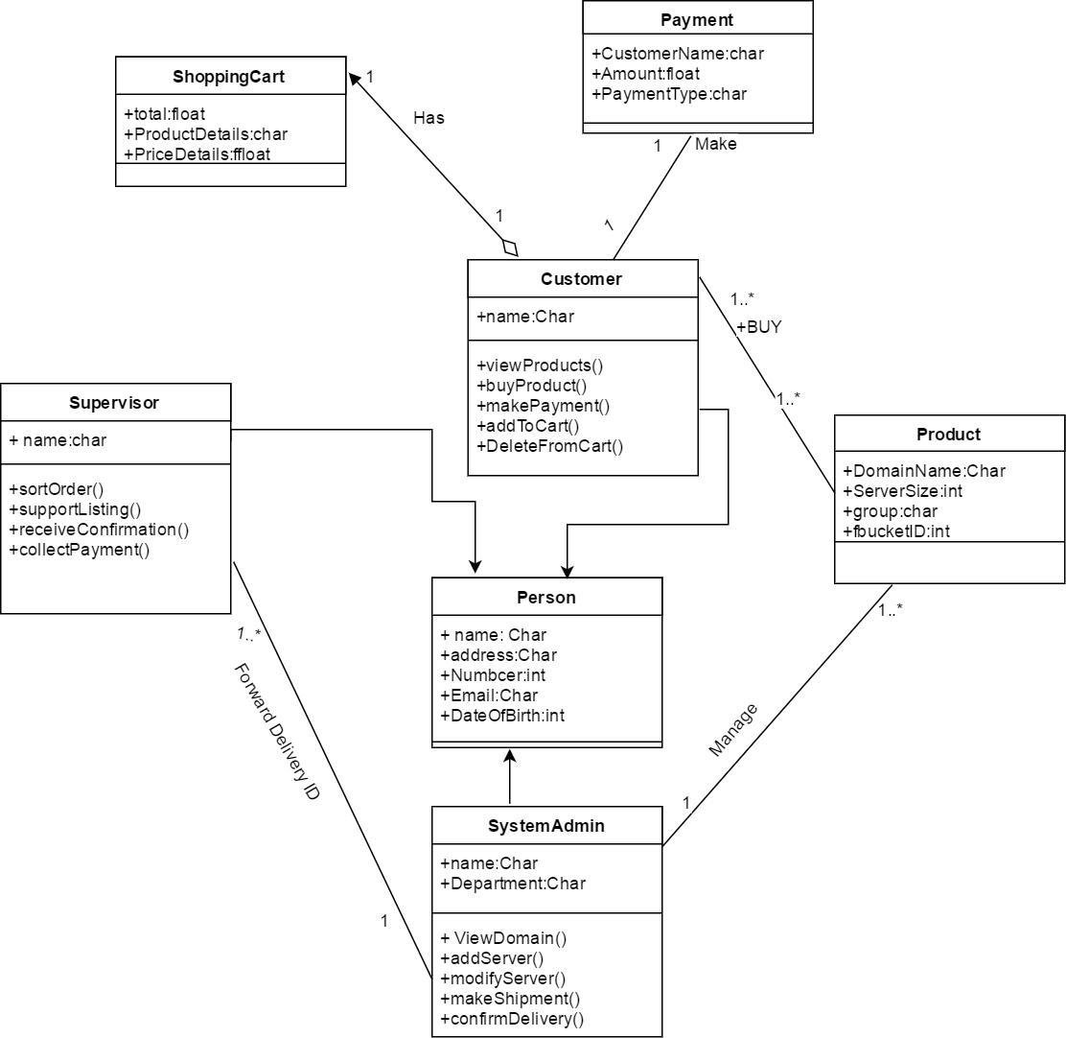



7

### STATE DIAGRAM

A state diagram is a graph of events and states. State is an abstraction of attribute values and object links. An event is something which happens in a time instant.

### State Diagram of Making Order

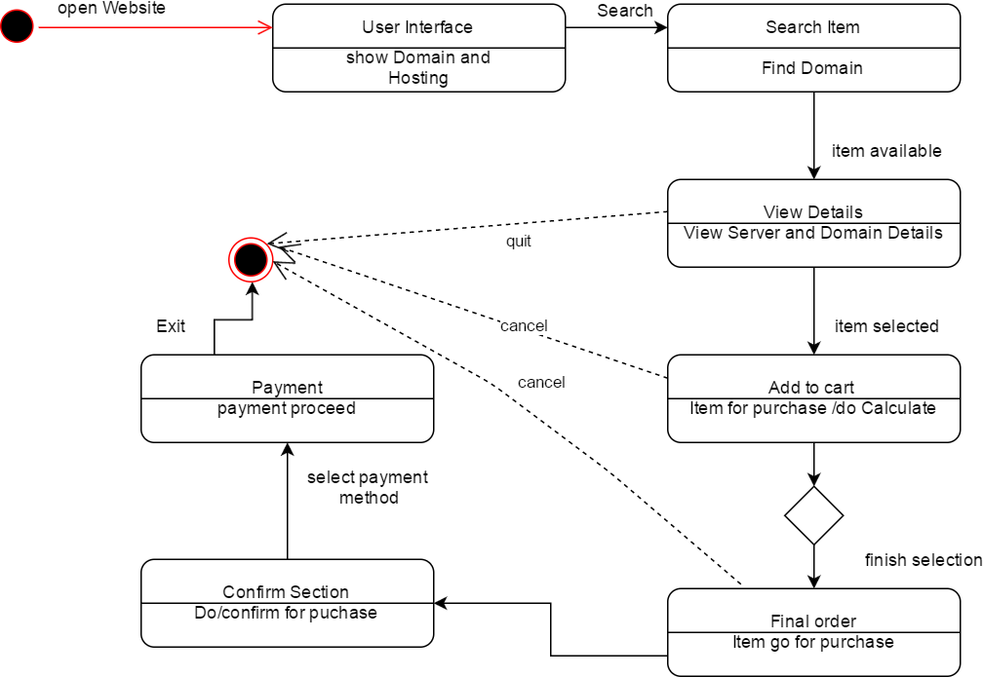



8

**State Diagram of Server allocation**

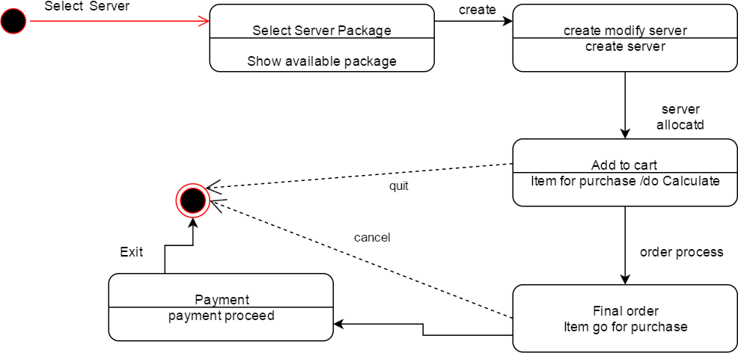

### CONCLUSION

In this report, a detailed UML documentation for a simulated Domain and hosting/server allocation and reserved . The UML diagrams used in this documentation are Use Case Diagram, Sequence Diagram, Activity Diagram, Class Diagram and State Chart Diagram. The project was supposed to design Internet based purchase and delivery with UML methods. The functions of the delivery system described in this paper are still limited to the class project; additional features are more likely needed in the real world.